1. **Formula:** 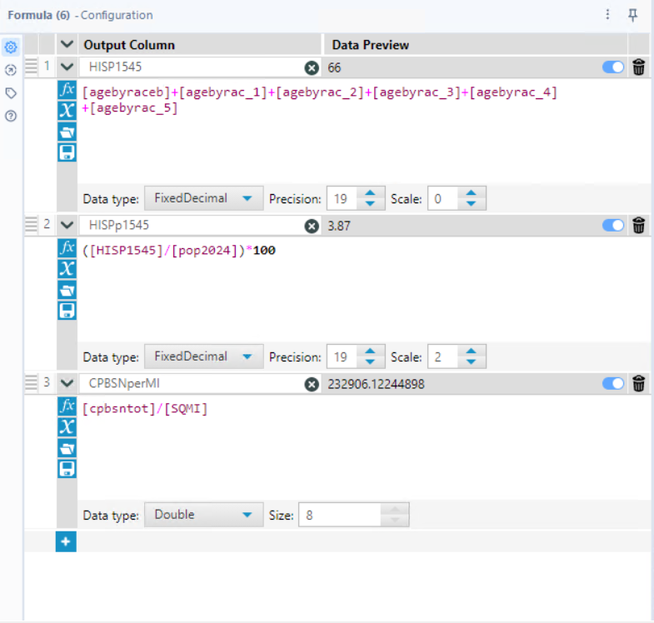
2. **Explain analyzes and interpret results:**

I want to filter for block groups with large numbers of people in my target user group (HISP1545, Hispanic females aged 15–44), so I only see those block groups on my map as I work to define a viable trade area. Therefore, I look for block groups with user group counts equal to or above the average + 1 standard deviation on my user-group population variable (HISP1545), across all block groups in my target state of New Mexico.

From the profile summary, I calculate this threshold as follows:  
Average = 161.55  
Standard Deviation = 118.82  
Threshold = 161 + 118 = 279

Thus, I will filter for block groups with 280 or more Hispanic females aged 15–44. These are the areas with the highest concentration of my user group, and will guide my outreach and planning efforts moving forward.

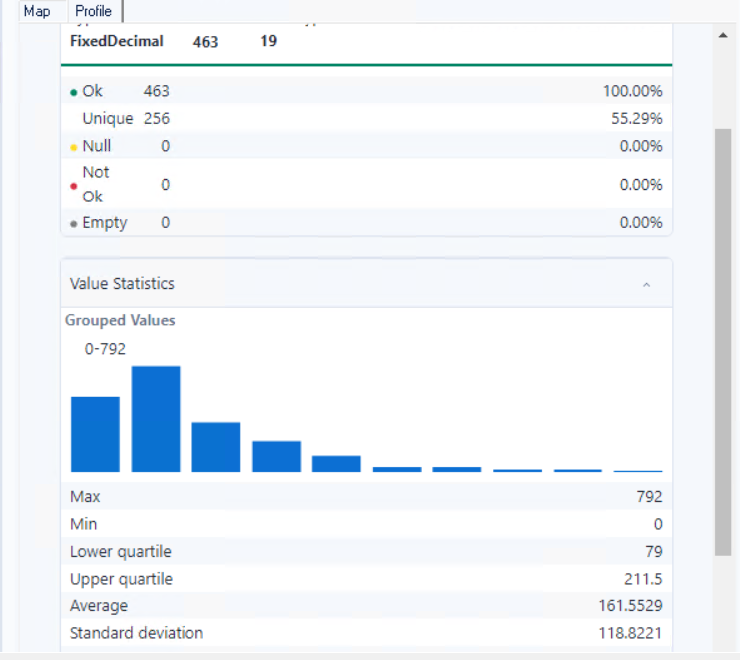

1. **Explain analyzes and interpret results:**

I am analyzing block groups in my target county of Bernalillo, NM to identify a suitable trade area for my project. I extracted the project data by block group using ArcGIS Pro, and then imported the shapefile into Alteryx to calculate key project variables—including the population count of Hispanic females aged 15–44 (HISP1545), the % of each block group’s population in my user group, and other relevant demographic metrics.

To ensure that the block groups I consider for my trade area have a strong concentration of my user group, I applied a filter for block groups with 279 or more Hispanic females aged 15–44, which is 1 standard deviation above the mean based on my earlier calculation.

As shown below, I identified 72 block groups meeting this threshold. On the map, many of these block groups are clustered within urban Albuquerque, suggesting there are multiple promising trade areas that I could target for outreach or pilot implementation in my project.

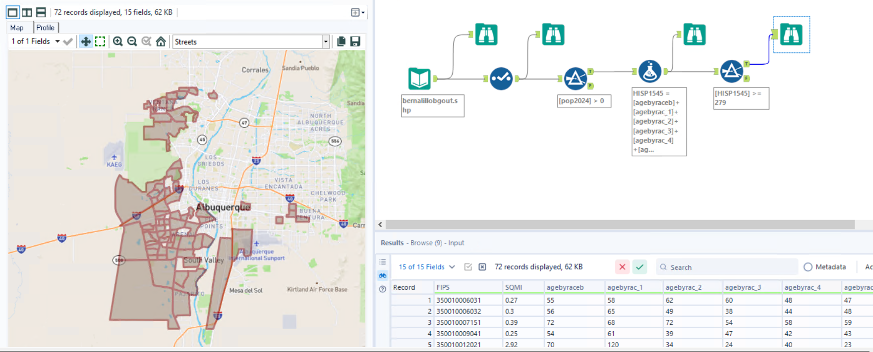

1. **SCREENSHOT MAP WITH TARGET ZIP CODE HIGHLIGHTED AS SHOWN BELOW**

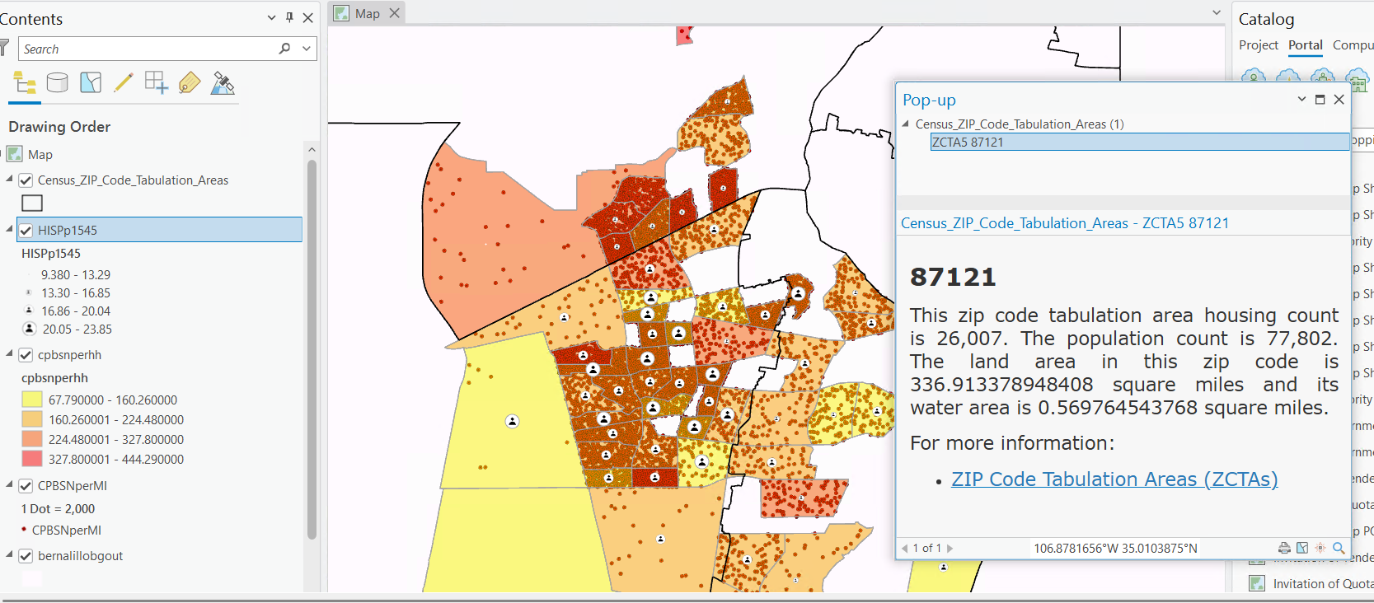

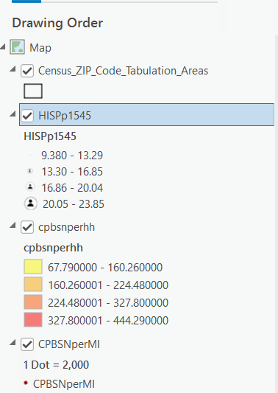

I have created a map of my target county, Bernalillo County, NM, showing the zip code tabulation areas (ZCTAs), including my focus zip code 87121. To build this map, I filtered for ZCTAs with 279+ Hispanic females aged 15–44, with 279 being the threshold (mean + 1 standard deviation) for block group populations in my earlier analysis. These ZCTAs are color-coded and symbolized to help identify promising trade areas.

* I have used a graduated person icon to show the percent of each ZCTA’s population made up of Hispanic females aged 15–44 (HISPp1545). The largest icons represent the most concentrated areas (20.05–23.85%), while smaller icons indicate lower concentrations (9.38–13.29%).
* I have used graduated colours, from yellow to dark red, to indicate average annual cosmetics/skincare spending per household. Red zones represent the highest spend levels ($327.80–$444.29), and yellow zones the lowest ($67.79–$160.26).
* I have added dot density symbols, where 1 dot = $2,000 of spending per square mile, to represent total skincare spend density (CPBSNperMI). More dots indicate higher total market potential due to population density, even if per-household spend is modest.

In my map, I observe both patterns:

* Some areas show high dot density but lower household spending (yellow/orange), suggesting lower-income but densely populated neighborhoods.
* Others show low density but high spend per household (dark red with few dots), indicating higher-income, low-density areas.

This variety suggests that the ZCTAs in and around 87121 are socioeconomically diverse, not homogenous. I plan to investigate this further by examining lifestyle segments and spending patterns in the next phase of my analysis.